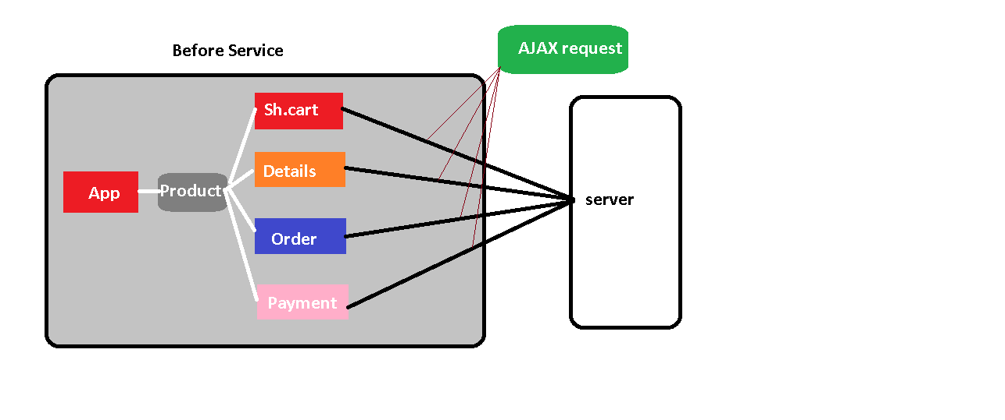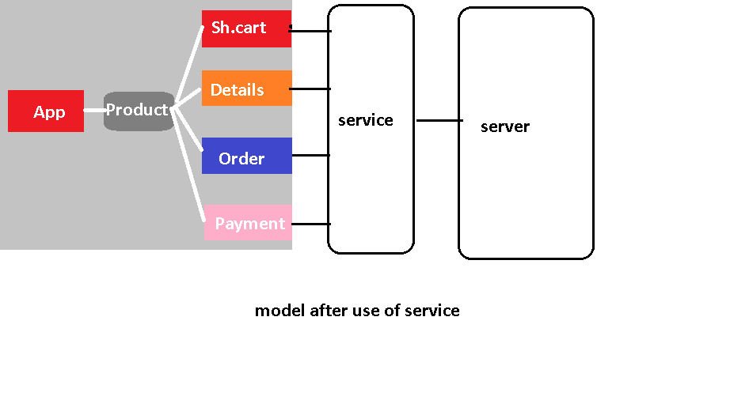

Create an app

* Ng new serviceapp
* Ng g c service-component

Create service

* Ng g s user

So it will prepare two files in app

User.service.ts

User.service.spec.ts

Register the service in app.module.ts

import { NgModule } from '@angular/core';

import { BrowserModule } from '@angular/platform-browser';

import { AppRoutingModule } from './app-routing.module';

import { AppComponent } from './app.component';

import { ServiceDemoComponent } from './service-demo/service-demo.component';

import { UserService } from './user.service';

@NgModule({

  declarations: [

    AppComponent,

    ServiceDemoComponent

  ],

  imports: [

    BrowserModule,

    AppRoutingModule

  ],

  providers: [UserService],

  bootstrap: [AppComponent]

})

export class AppModule { }

now we can inject the service in any component that we have prepared already

let’s inject the service in servide-demo component

open service-demo.component.ts

import { Component, OnInit } from '@angular/core';

import { UserService } from '../user.service';

@Component({

  selector: 'app-service-demo',

  templateUrl: './service-demo.component.html',

  styleUrls: ['./service-demo.component.css']

})

export class ServiceDemoComponent implements OnInit {

  constructor(private service:UserService) { }

  ngOnInit(): void {

  }

}